Data Source:

<https://www.sheffield.ac.uk/mash/statistics/datasets>.

Data Description: Birthweight

This dataset contains information on newborn babies and their parents. It contains mostly continuous variables (although some have only a few values e.g. number of cigarettes smoked per day) and is most useful for correlation and regression. The birthweights of the babies who mothers smoked have been adjusted slightly to exaggerate the differences between mothers who smoked and didn’t smoke so students can see the difference more clearly in a scatterplot with gestational age and scatter colour coded by smoking status.

Research Question: Do smokers have lighter babies?

**Independent T-Test**

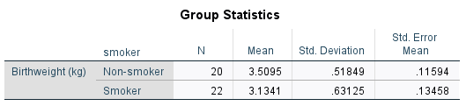

N is the sample size of newborn babies from non-smokers and smoker mothers which are 20 and 22 respectively. The mean is the average newborn Birthweight, 3.51 for non-smoker and 3.13, for smoker respectively. The standard deviation was .52 for non-smoker and .63, for smoker respectively.

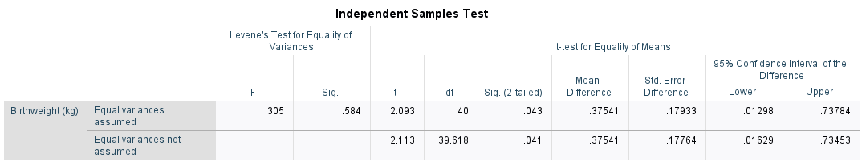

The table above provided the F-value and the level of significance Levene’s test of equality of variance, .584. The degree of freedom, df =40, was obtained by subtracting 1 from each sample sizes and summing both together. The mean difference on the test variable Birthweight, .375, was obtained by subtraction the mean of smokers from the mean of non-smokers. The positive value of the t value indicates that the mean amount of Birthweight for non-smoking mothers is significantly greater than the smoking mothers.

In this report, the variances are close, consequently, the standard t test, t(40) = 2.093, p = .043, and the t test value for unequal variances t(39.618) = 2.113, yield comparable results.

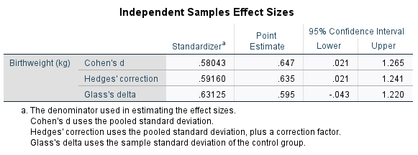

**APA for Independent t test**

An independent samples t test was conducted to evaluate if mother that smokes have lighter babies. The test was significant, t(40) = 2.093, p = .043. As hypothesized, the nonsmoking mothers [M=3.51, SD = .52] have newborn babies on average that weigh more than the newborn babies from mothers that smoke [M = 3.13, SD = .63]. The effect size of (d = .65) was intermediate and the 95% confident interval ranges from .021 to 1.265.

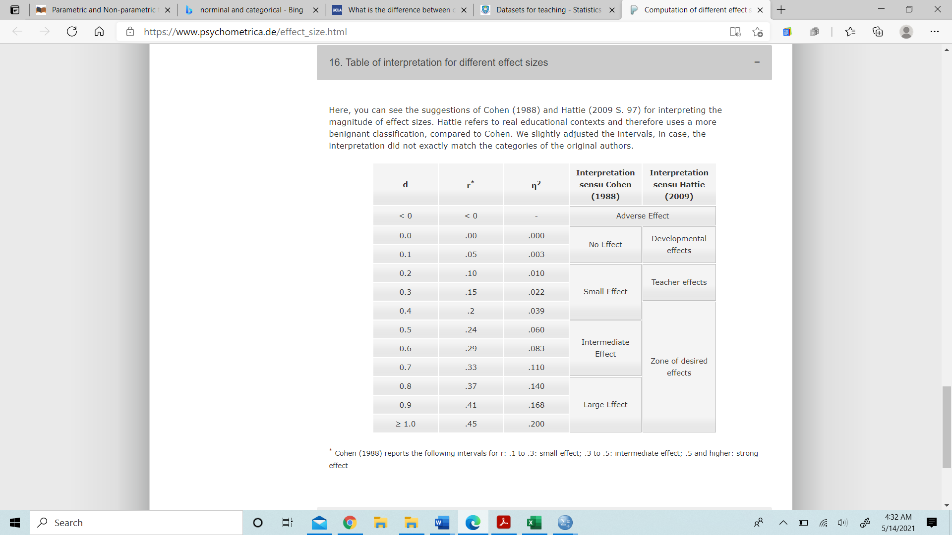

Figure 3: Effect Size Interpretation.

**Mann-Whitney U test**

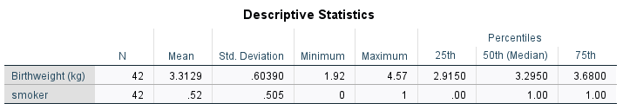

N is the total sample sizes of the dependent (newborn birthweight) and independent (smoking and non-smoking mothers) variables 42 respectively for both. The mean is the average of newborn Birthweight, 3.31 and of independent variable (smoking and non-smoking mothers) .52. The standard deviation was .604 for newborn birthweight and .505, for independent variables (smoking and non-smoking mothers) respectively. The minimum values were, 1.92 and 0 for dependent (newborn birthweight) and independent (smoking and non-smoking mothers) variables and the maximum values were, 4.57 and 1 for dependent (newborn birthweight) and independent (smoking and non-smoking mothers) variables respectively. The 25th, 50th and 75th percentiles of the dependent (newborn birthweight) and independent (smoking and non-smoking mothers) variables respectively were also provided on the table.

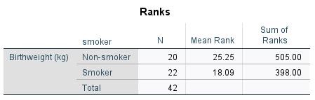

The table above provided N which is the sample size of newborn babies from non-smokers and smoker mothers which are 20 and 22 respectively. Their mean rank and sum of ranks were also provided.

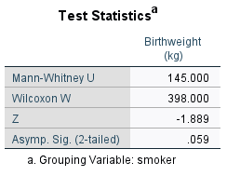

The table above provided the Mann-Whitney U value, 145 and the p-value, .059 which are essential in finding the effect later.

**APA for** **Mann-Whitney U test**

A Mann Whitney U test was conducted to evaluate the hypothesis that mothers who smokes give birth to lighter babies compared to non-smoking mothers. The results of the test were nonsignificant (p = 0.059), p>.05. Even though, according to the mean rank, the smoking mother was ranked 18.09, which was less compared to 25.25 ranked for non-smoking mothers. The relationship between the two groups according to ɳ2 = 0.085 and dcohen = 0.609 revealed a intermediate effect size. Therefore, it is evident that, the data was parametric and using non-parameter statistical analysis could result in a false interpretation in terms of statistical significances.